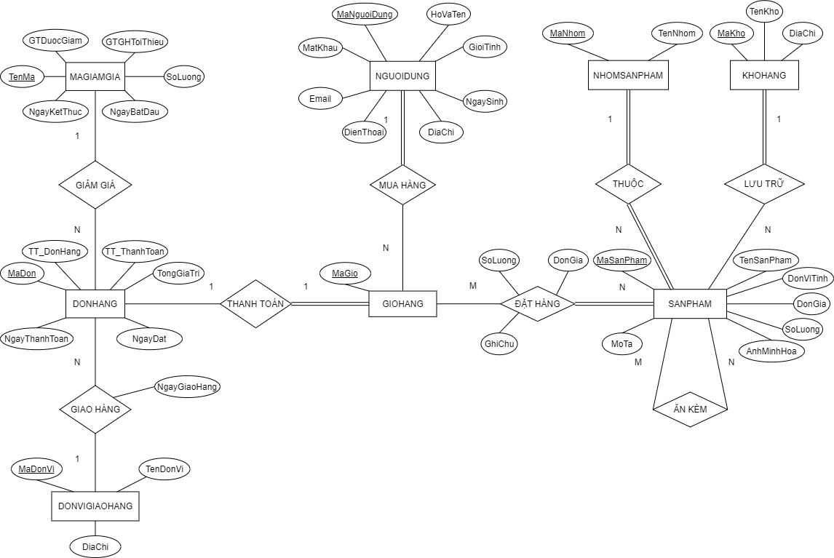

NGUOIDUNG(MaNguoiDung, HoVaTen, GioiTinh, NgaySinh, DiaChi, DienThoai, Email, MatKhau)

NHOMSANPHAM(MaNhom, TenNhom)

KHOHANG(MaKho, TenKho, DiaChi)

SANPHAM(MaSanPham, TenSanPham, DonViTinh, DonGia, SoLuong, AnhMinhHoa, MaNhom, MaKho, MoTa)

ANKEM(MaMonAnChinh, MaDoAnKem)

GIOHANG(MaGio, MaNguoiDung)

DATHANG(MaGio, MaSanPham, SoLuong, DonGia, GhiChu)

MAGIAMGIA(TenMa, GT_DuocGiam, GTGH_ToiThieu, SoLuong, NgayBatDau, NgayKetThuc)

DONVIGIAOHANG(MaDonVi, TenDonVi, DiaChi)

DONHANG(MaDon, MaGio, MaGiamGia, MaDonViGiaoHang, TT_DonHang, TT_ThanhToan, TongGiaTri, NgayDat, NgayGiaoHang, NgayThanhToan)

